**API Testing Screenshots:**

**URL: /**

**Success case:**

GET: http://127.0.0.1:5000/

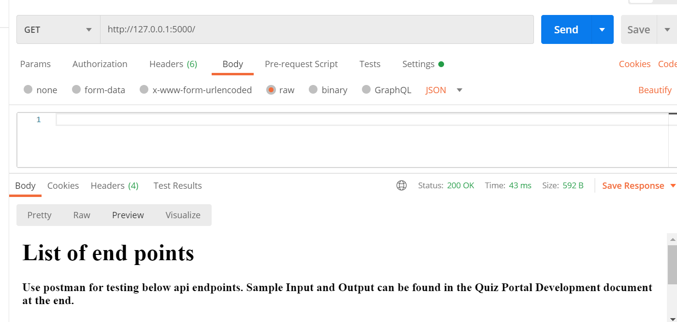

**Failure case:**

Any HTTP Request method other than GET would give below response.

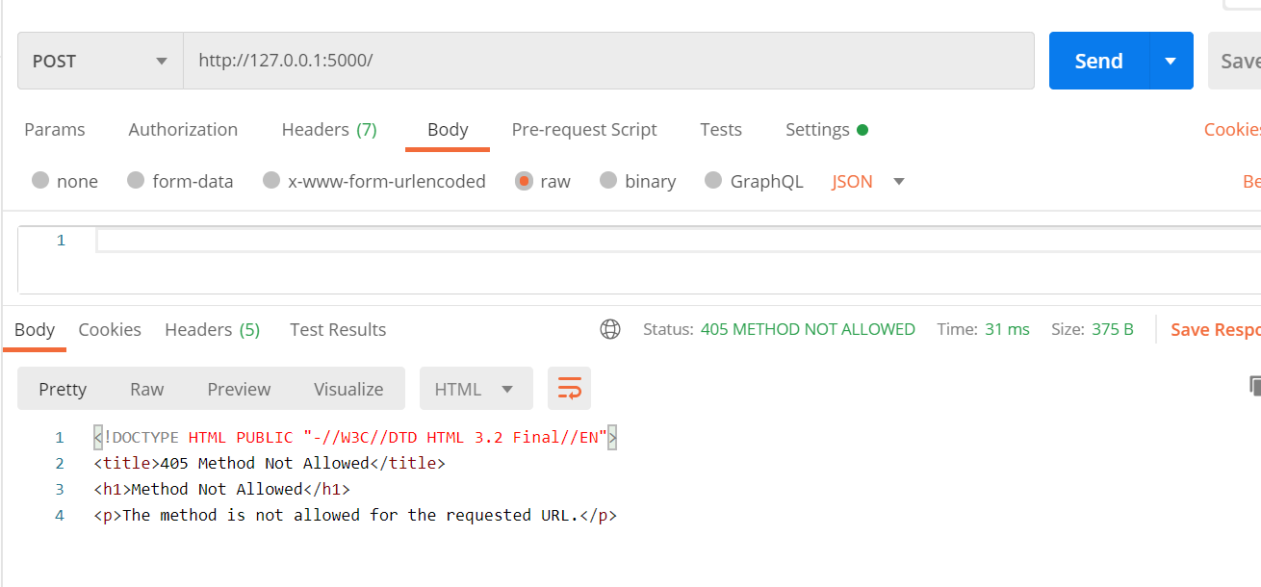

**URL: /user/**

**Success case:**

POST: http://127.0.0.1:5000/user/

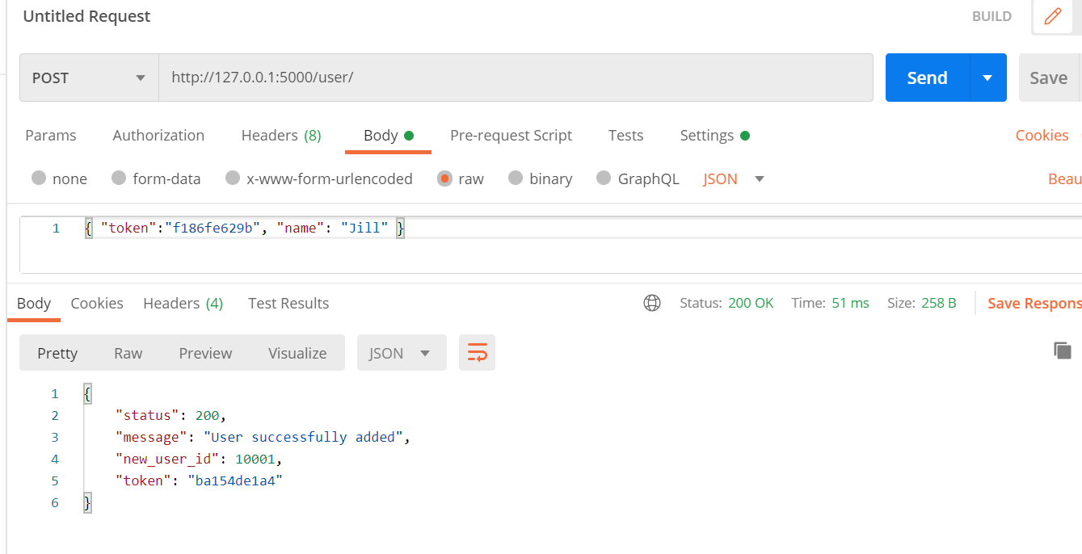



DELETE: <http://127.0.0.1:5000/user/>

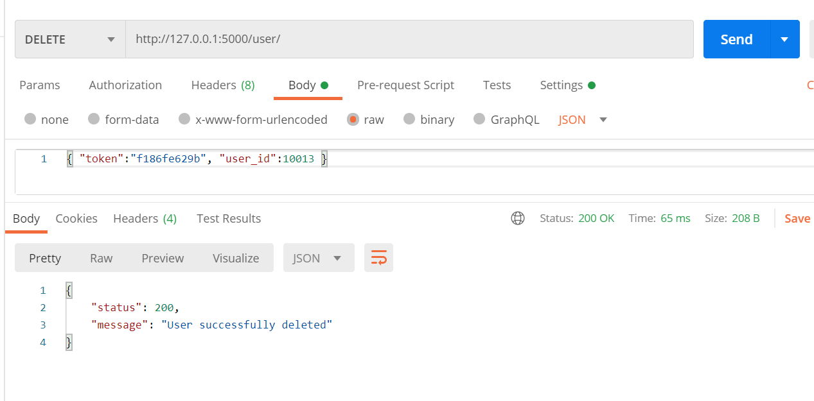

**Failure case:**

POST: http://127.0.0.1:5000/user/

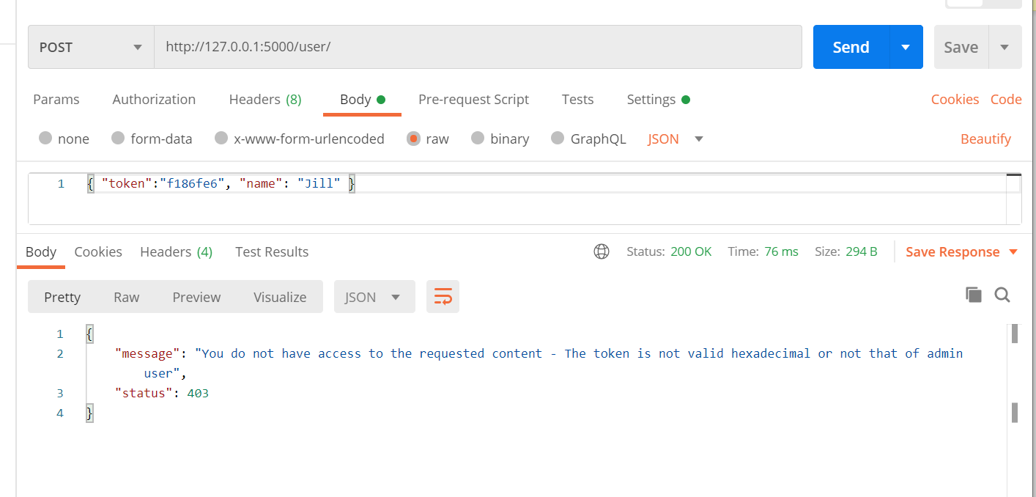

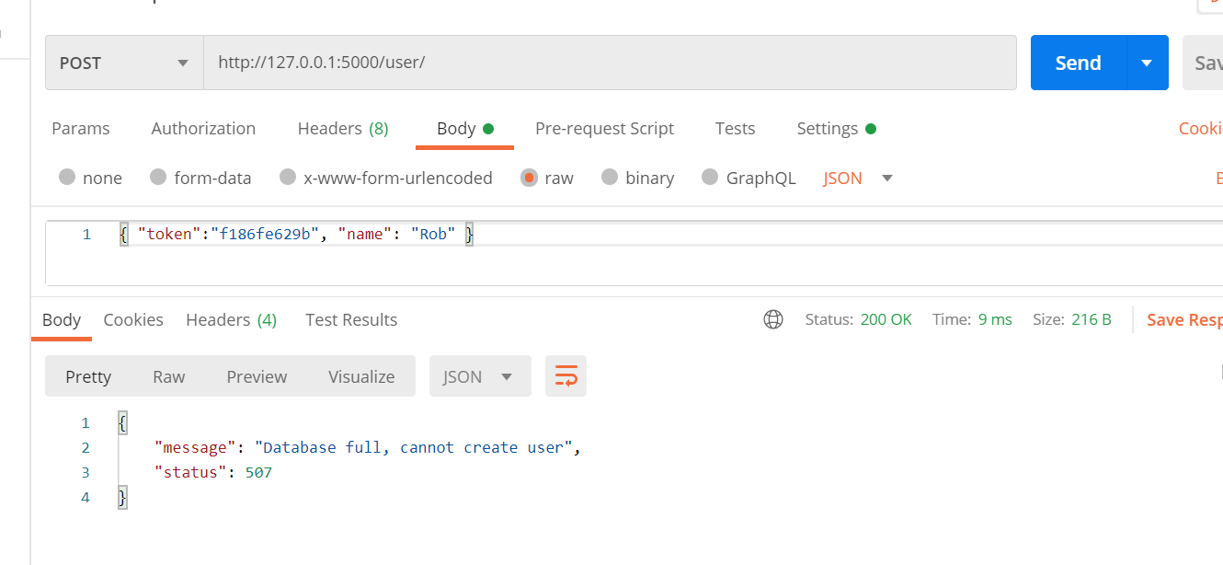

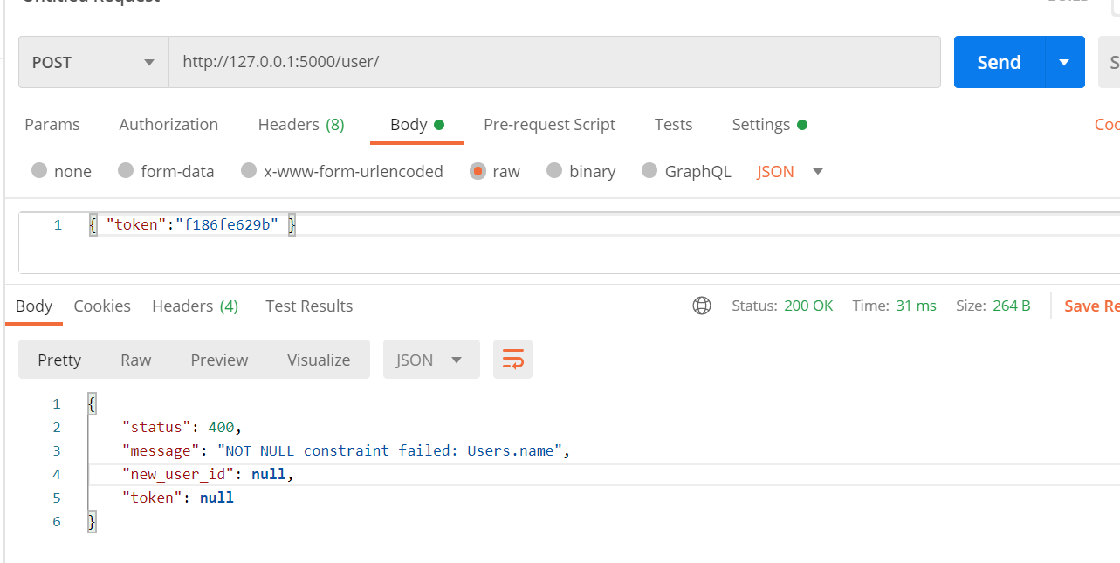

DELETE: <http://127.0.0.1:5000/user/>

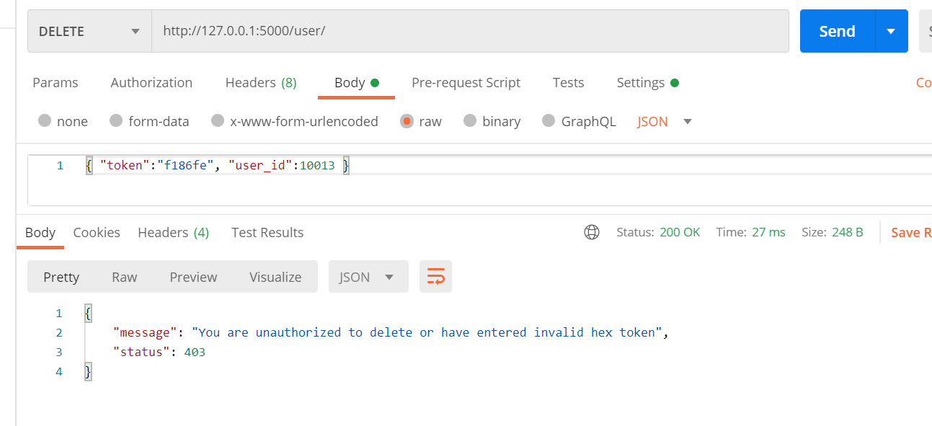

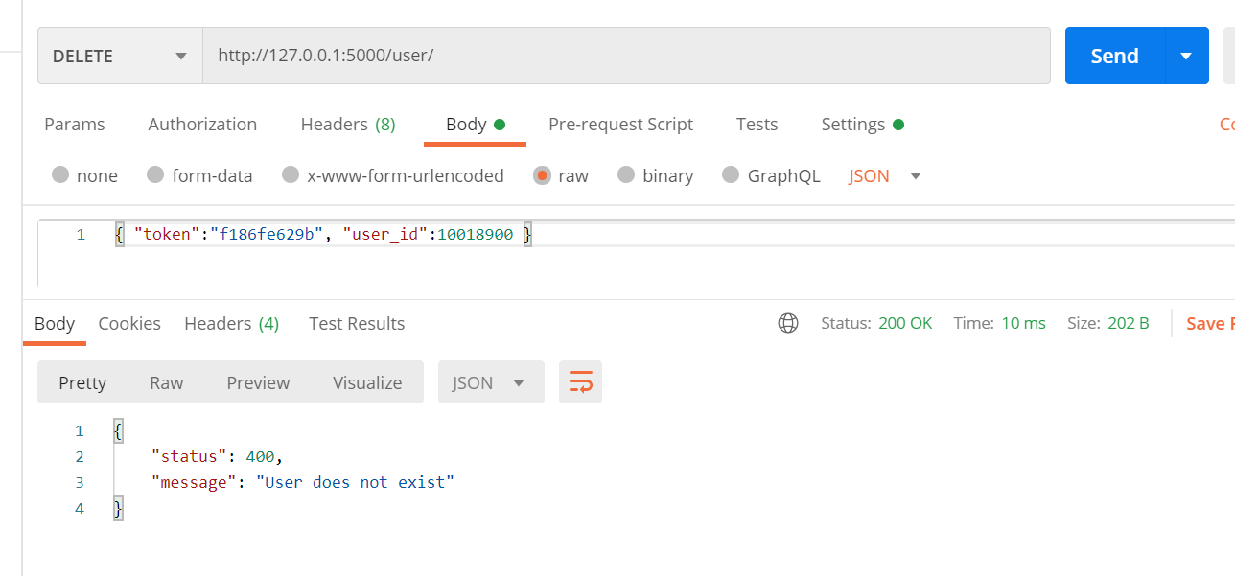

**URL: /question/**

**Success case:**

POST: http://127.0.0.1:5000/question/

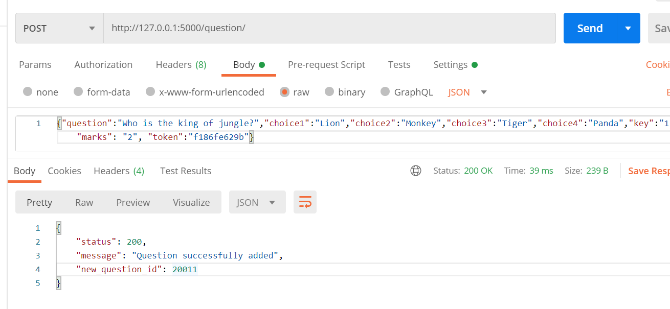

DELETE: http://127.0.0.1:5000/question/

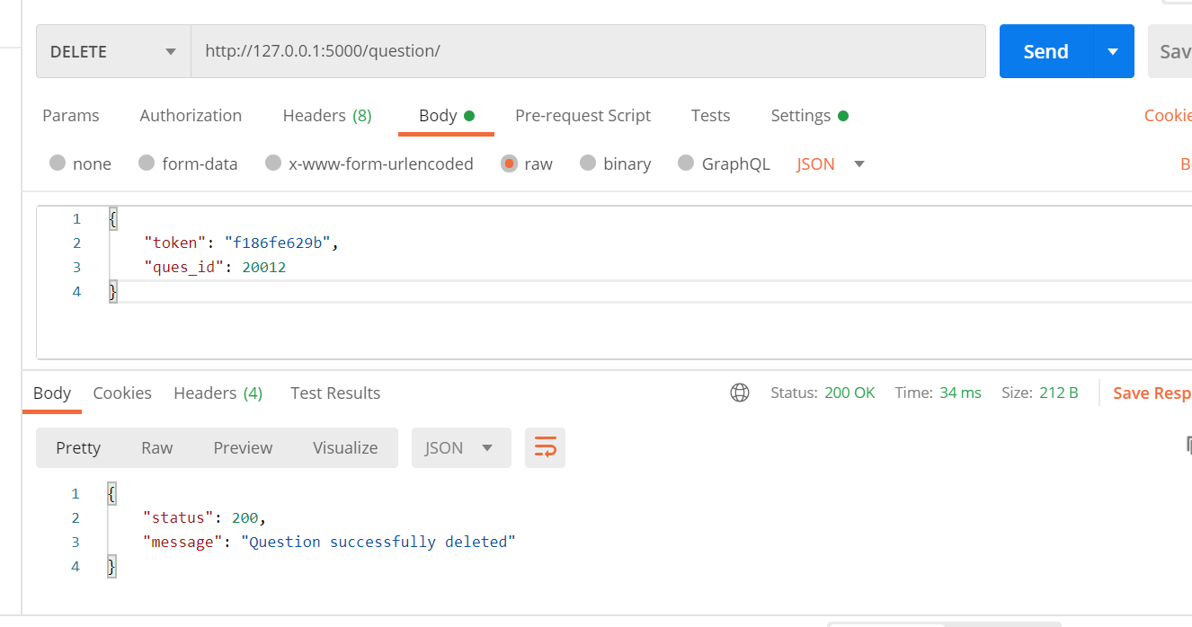

**Failure case:**

POST: http://127.0.0.1:5000/question/

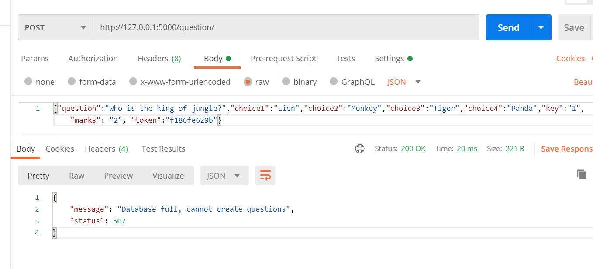

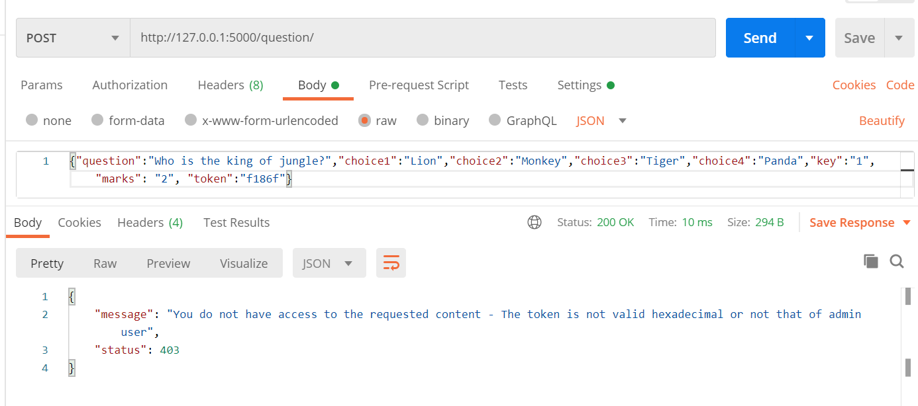

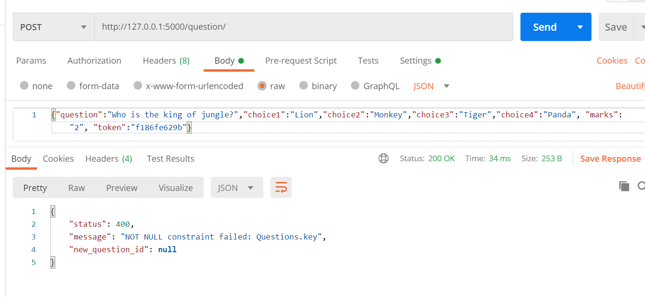

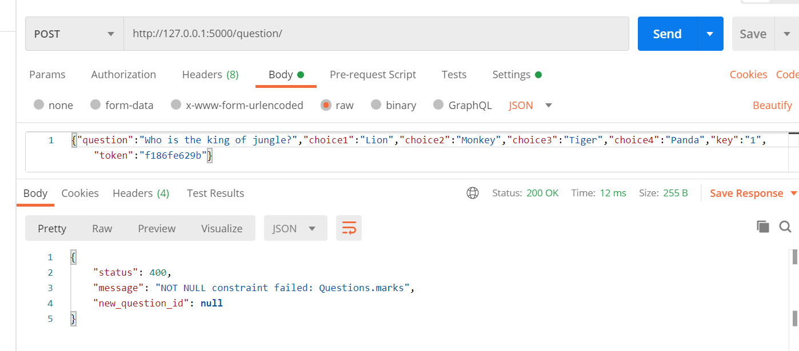

DELETE: http://127.0.0.1:5000/question/

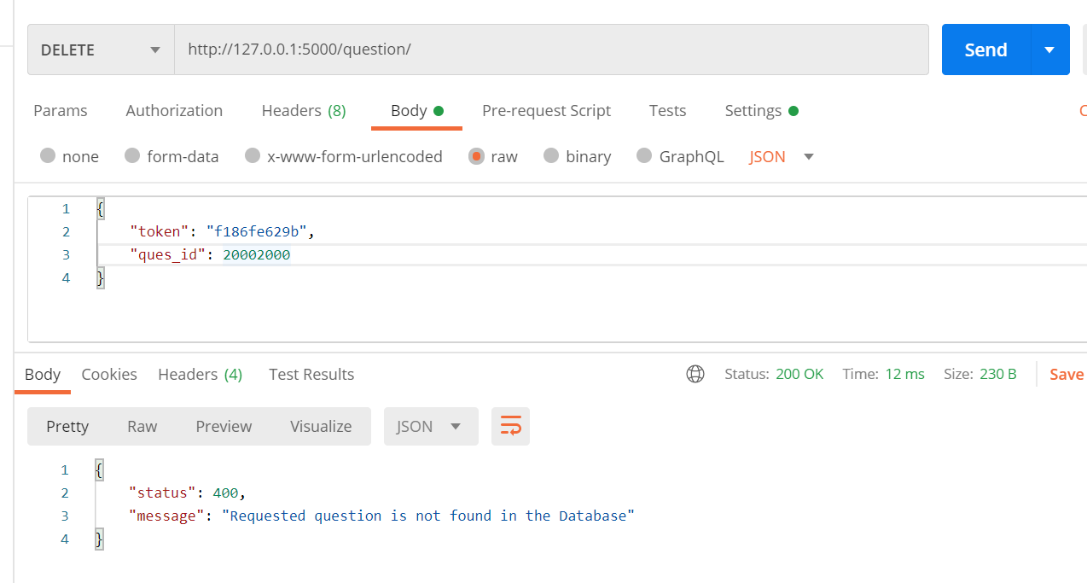

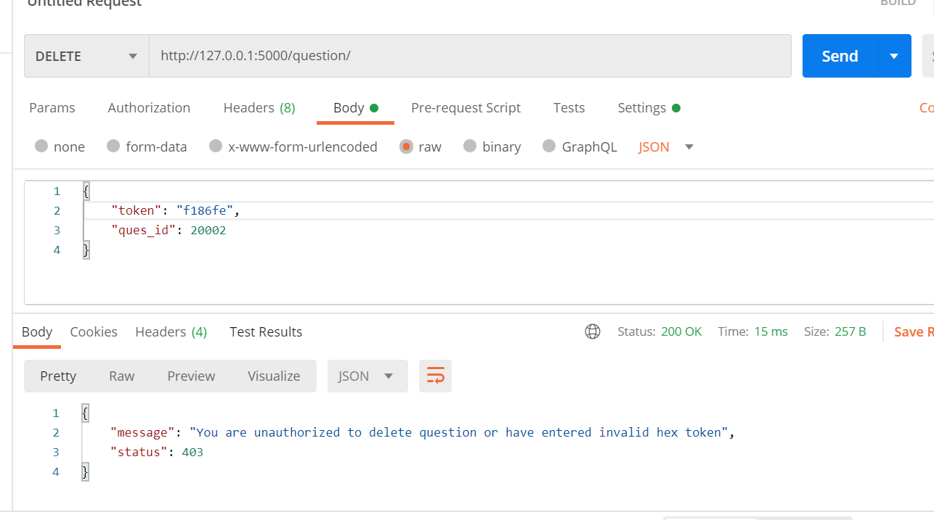

**URL: /quiz/**

**Success case:**

GET: <http://127.0.0.1:5000/quiz/>

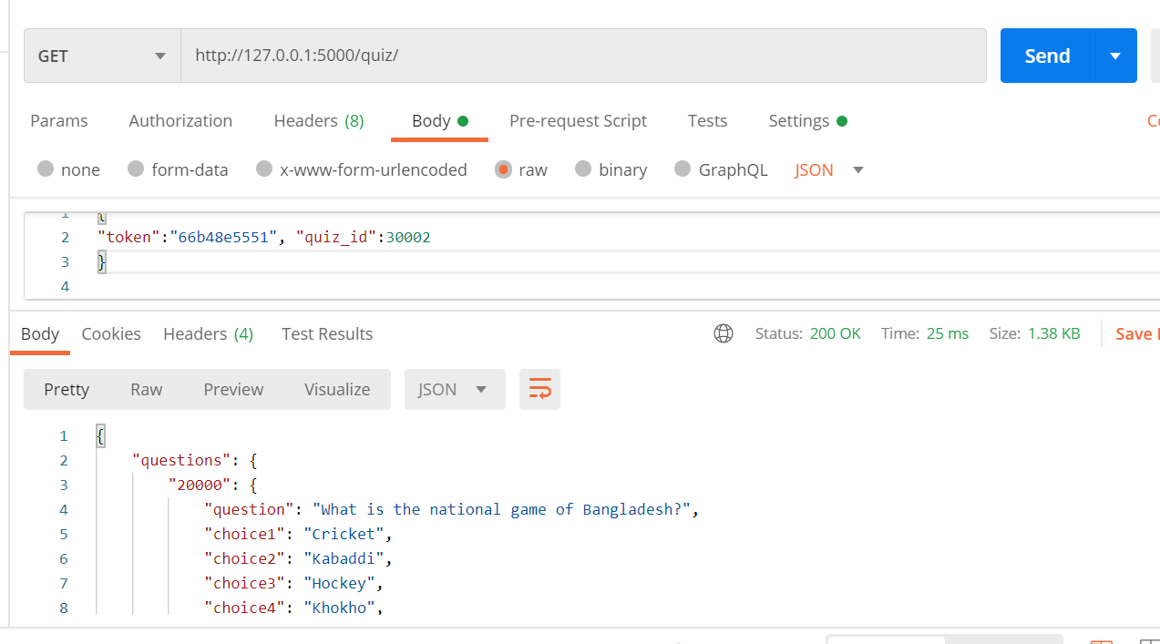

Sample response:

{

"questions": {

"20000": {

"question": "What is the national game of Bangladesh?",

"choice1": "Cricket",

"choice2": "Kabaddi",

"choice3": "Hockey",

"choice4": "Khokho",

"marks": 2,

"remarks": "Sports"

},

"20001": {

"question": "How many sides are there in a triangle?",

"choice1": "one",

"choice2": "two",

"choice3": "three",

"choice4": "four",

"marks": 2,

"remarks": ""

},

"20002": {

"question": "Which festival is known as the festival of colors?",

"choice1": "Diwali",

"choice2": "Sankranthi",

"choice3": "Onam",

"choice4": "Holi",

"marks": 2,

"remarks": "Festival"

},

"20004": {

"question": "How many weeks are there in one year?",

"choice1": "51",

"choice2": "52",

"choice3": "41",

"choice4": "60",

"marks": 2,

"remarks": ""

},

"20007": {

"question": "How many lungs does the human body have?",

"choice1": "3",

"choice2": "4",

"choice3": "5",

"choice4": "2",

"marks": 2,

"remarks": ""

}

}

}

POST: <http://127.0.0.1:5000/quiz/>

Created a new quiz if it doesn’t exit and tests the quiz instance

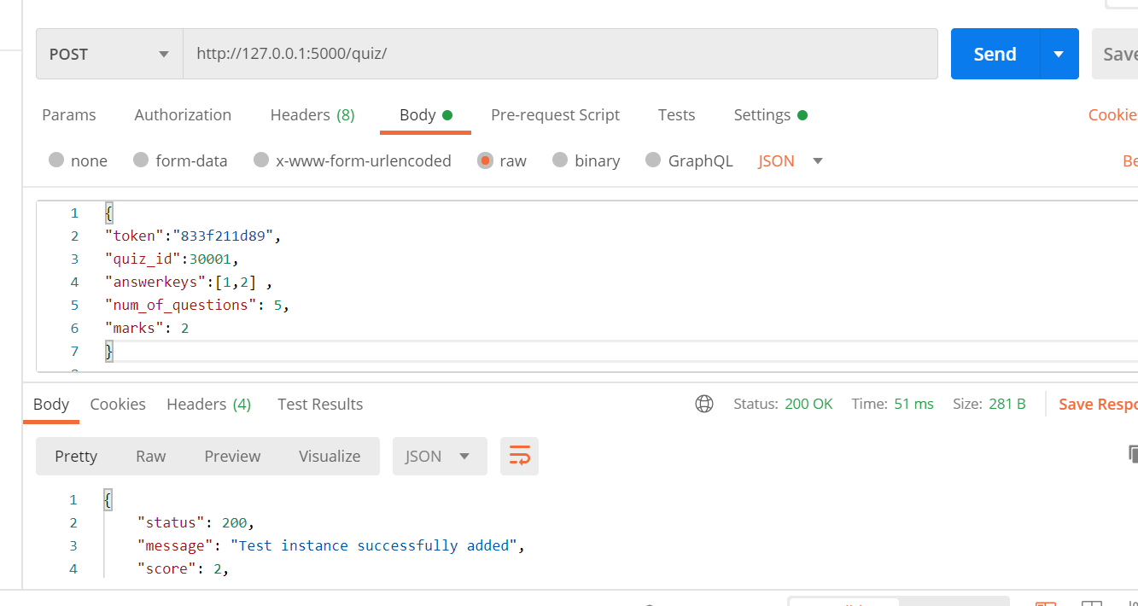

Sample response:

{

"status": 200,

"message": "Test instance successfully added",

"score": 2,

"result": [

2,

0,

0,

0

]

}

When the quiz exists, it tests the quiz instance

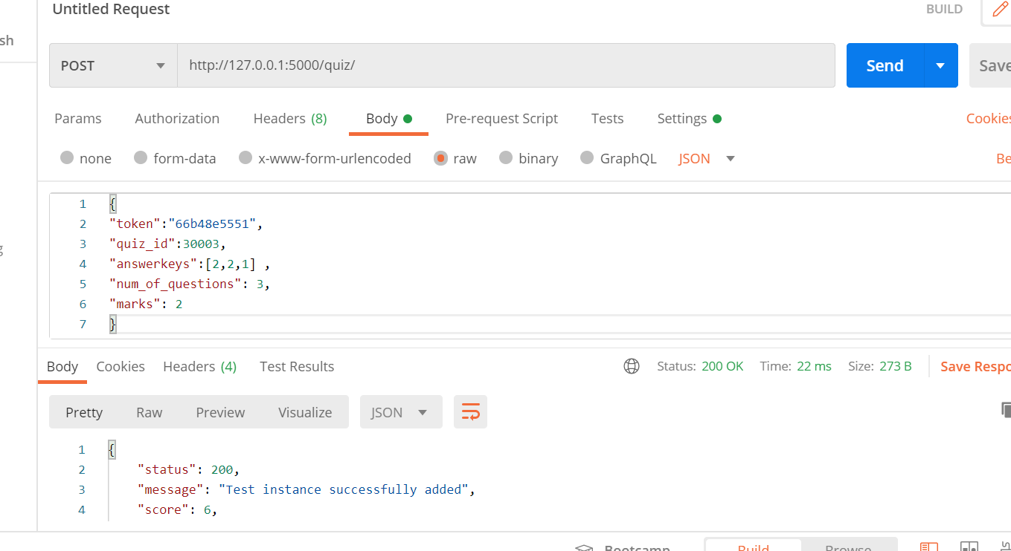

Sample response:

{

"status": 200,

"message": "Test instance successfully added",

"score": 6,

"result": [

2,

2,

2

]

}

**Failure case:**

GET: http://127.0.0.1:5000/quiz/

Trying to access the quizID that does not exist

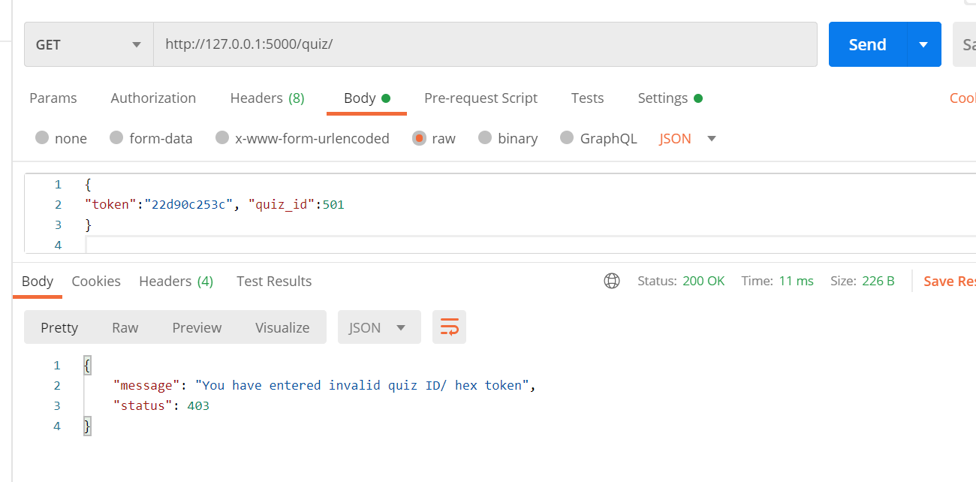

Token is invalid

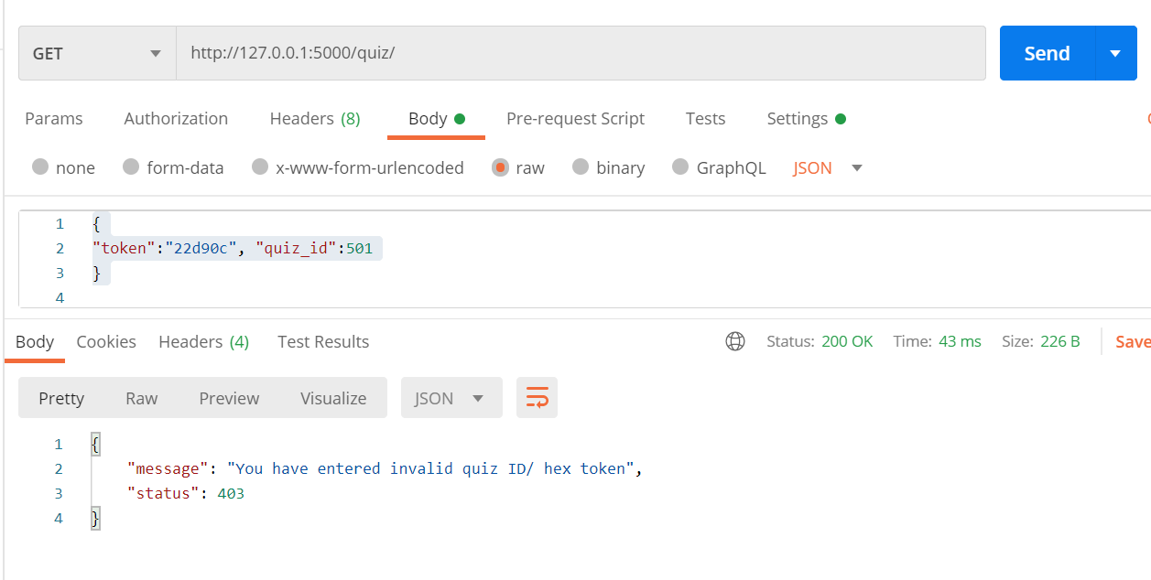

POST: http://127.0.0.1:5000/quiz/

Invalid token

